CPE301 – SPRING 2019

Design Assignment 4A

Student Name: John Duriman

Student #: 5002373995

Student Email: duriman@unlv.nevada.edu

Primary Github address: https://github.com/johnduriman/pirahnaplant.git

Directory: pirahnaplant/Design Assignments/DA4A/

Submit the following for all Labs:

1. In the document, for each task submit the modified or included code (only) with highlights and justifications of the modifications. Also, include the comments.
2. Use the previously create a Github repository with a random name (no CPE/301, Lastname, Firstname). Place all labs under the root folder ESD301/DA, sub-folder named LABXX, with one document and one video link file for each lab, place modified asm/c files named as LabXX-TYY.asm/c.
3. If multiple asm/c files or other libraries are used, create a folder LabXX-TYY and place these files inside the folder.
4. The folder should have a) Word document (see template), b) source code file(s) and other include files, c) text file with youtube video links (see template).

1. **COMPONENTS LIST AND CONNECTION BLOCK DIAGRAM w/ PINS**

List of Components used:

Atmega328P

DC motor

L293D

Breadboard

Wires

Block diagram with pins used in the Atmega328P

I used Timer 0 for OC0A and OC0B

PC0 for the potentiometer

VCC and GND of course to power my bread board

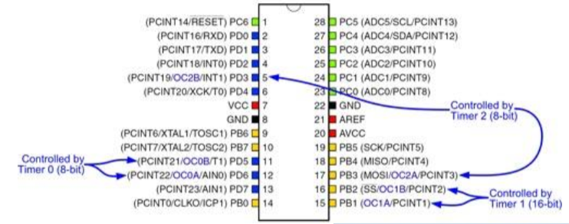

1. **INITIAL/MODIFIED/DEVELOPED CODE OF TASK 1/A**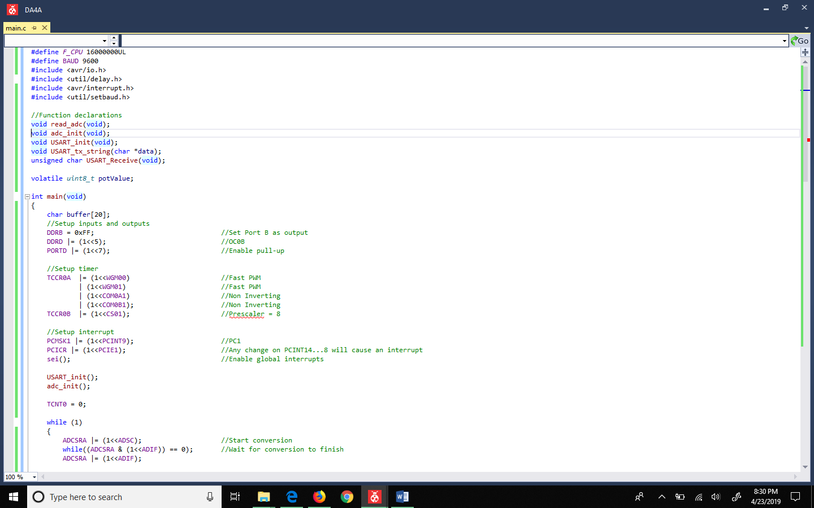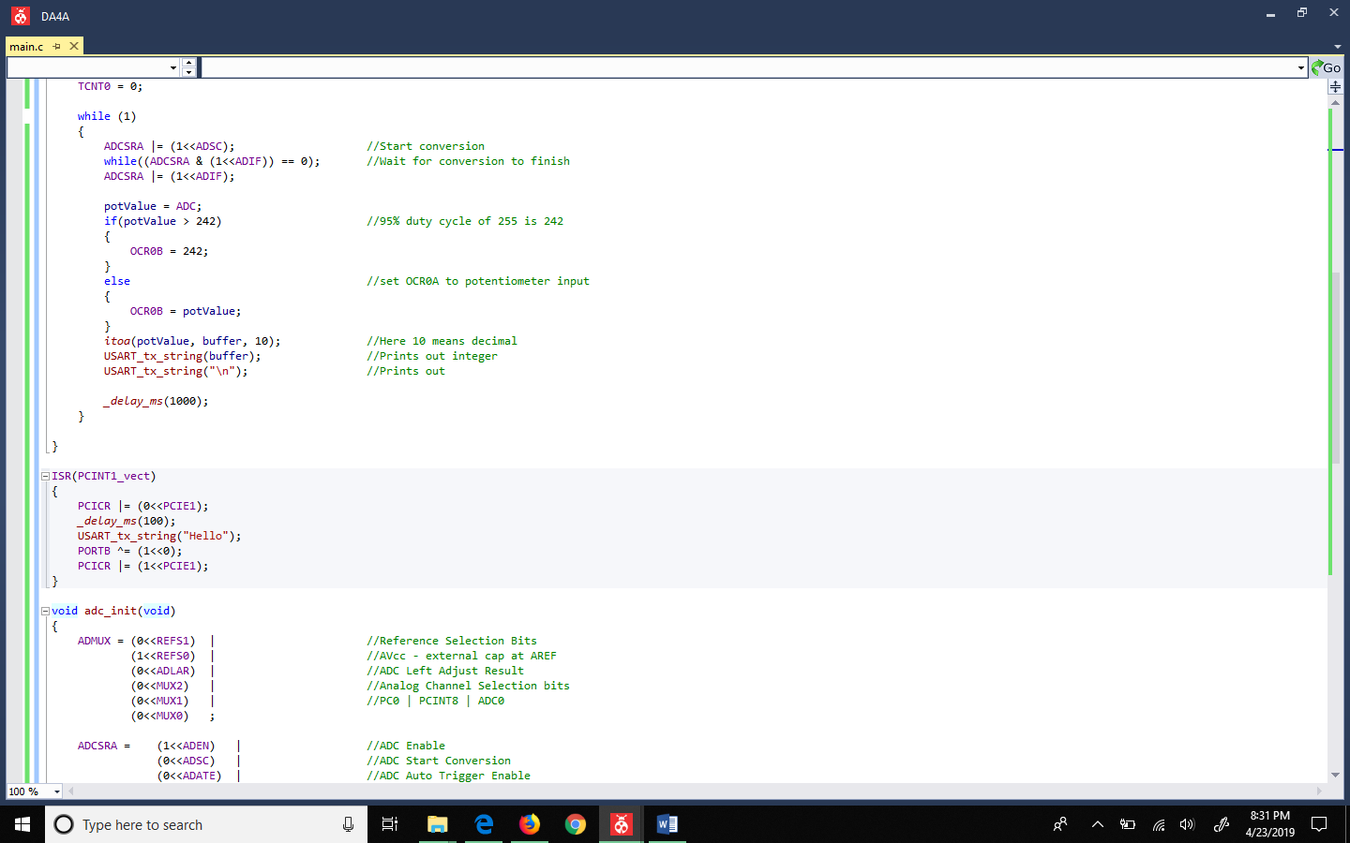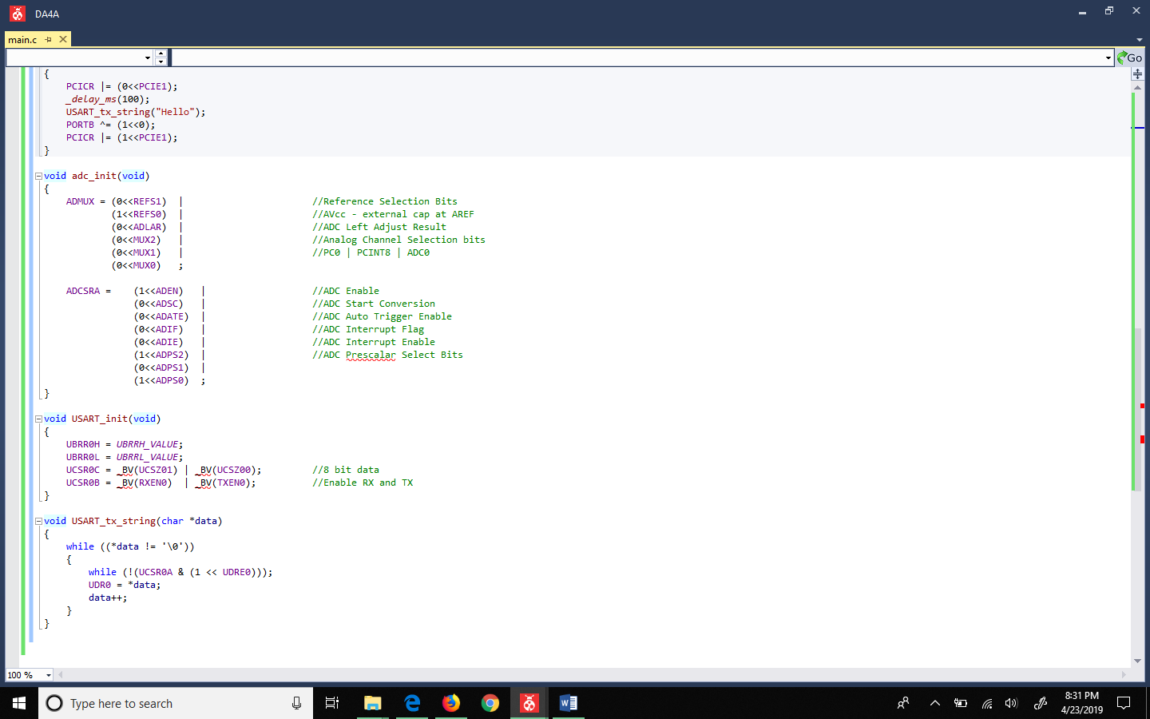
2. **SCREENSHOTS OF EACH TASK OUTPUT (ATMEL STUDIO OUTPUT)**

Used UART to output potentiometer values

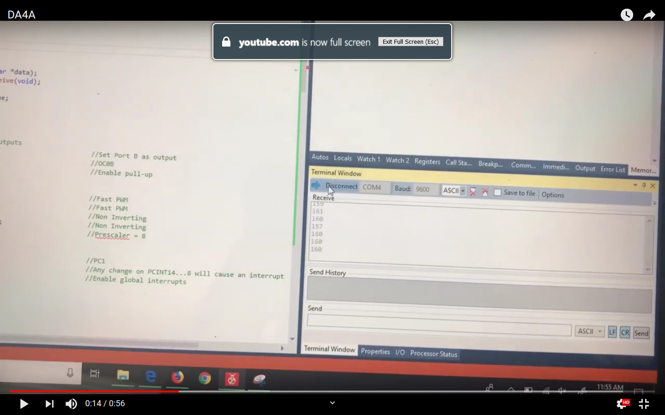

1. **SCREENSHOT OF EACH DEMO (BOARD SETUP)**

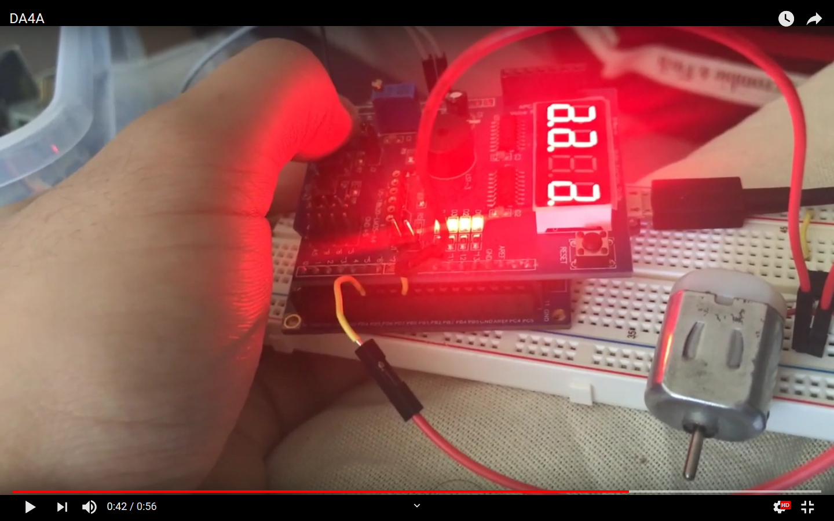

1. **VIDEO LINKS OF EACH DEMO**

https://youtu.be/QYZYdwh1XOY

1. **GITHUB LINK OF THIS DA**

https://github.com/johnduriman/pirahnaplant.git

**Student Academic Misconduct Policy**

<http://studentconduct.unlv.edu/misconduct/policy.html>

“This assignment submission is my own, original work”.

John Duriman